DATE: 21.02.2020
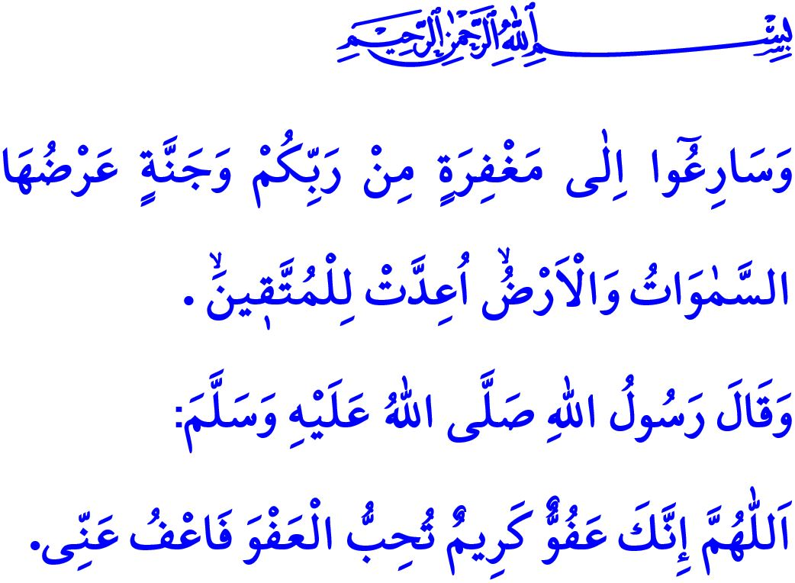
TOWARDS THE SPIRITUAL CLIMATE OF THE THREE HOLY MONTHS
Honorable Muslims!
In the verse I have recited, Allah the Almighty states, “And hasten to forgiveness from your Lord and a garden as wide as the heavens and earth, prepared for the righteous.”
In the hadith I have read, the Prophet Muhammad teaches us the following du'a: “O Allah, You are Most Forgiving, and You love forgiveness, and so forgive me.”
Dear Believers!
Over us is the shade of the three holy months that bring barakah to our life and peace to our soul through the countless blessings and ikhsan of Allah the Almighty. We will have reached the month of Rajab the next Tuesday. Next Thursday night turning to Friday, we will be enjoying the Raghaib, inshallah.
Endless praise be to Allah the Almighty for allowing us to reach these spiritual days, and salat and salam be upon the Prophet Muhammad for teaching his ummah the worship and obedience, tawbah and istighfar, and du'a and supplication.
Dear Muslims!
The three holy months denote waking up from heedlessness (ghaflat) and getting oneself purified through the awareness of servitude to Allah. The three holy months are among the rare times the coming of which we long for every year. These are the months in which the divine mercy and forgiveness embrace all creation and Muslims gravitate toward worshiping together.
The first door opening to Allah the Almighty's endless blessings for His servants is the month of Rajab. It is the sign of Muslims’ iman and seeking refugee in Allah; and their loyalty and affection to Prophet Muhammad (saw).

Dear Believers!
Two holy nights in the month of Rajab come over in our hearts as guests. One of them is the Raghaib night. Raghaib refers to our efforts to direct all our wishes and desires to obtaining the consent of Allah. The Raghaib night teaches us that our only true achievement in this life that slips away is to turn to Allah and keep our promise of servitude to Him.
The other holy night in this month is the Mi’raj night that brings to mind the Masjid al-Aqsa as Prophet Muhammad's entrustment to his ummah. The Mi’raj night reminds us to move ourselves from material desires to spiritual values and lifting ourselves up from what is temporary to what is eternal.
Honorable Believers!
After the month of Rajab welcomes us the month of Sha'ban in which we prepare ourselves spiritually and physically for the month of Ramadan. Shining in the middle of the month of Sha’ban, the Bara’ah night makes us think that saving ourselves from sorrow and divine punishment and attaining forgiveness and peace lie in the servitude to Allah (swt).
Ramadan, the beginning of which denotes mercy, the middle of which forgiveness, and the end of which salvation from hell, is the last of the three holy months. Ramadan is the month of fasting, Qur’an, spending in the cause of Allah, zakat, purification, and contemplation. Towards the end of Ramadan we celebrate the Laylat al-Qadr, which is better and more bountiful in divine blessings than a thousand months for those who know its value. And finally, with the happiness of being obedient servants of Allah, we make it to the Eid al-Fitr.
Dear Muslims!
Let us regard the three holy months as an opportunity to be attached to Allah from heart, duly worship Him, and lead a life in accordance with good morals. Let us repent for our wrongs and sins. Let us quit our bad habits if we have any. Let us open a brand new page for the right, truth, good, and nice. Let us carry joy and happiness to sad hearts. Let us purify ourselves from the feeling of “I” and get the feeling of “we”. Let us thus attain peace in this world and in the Hereafter.
I would like to take this opportunity to pray to Allah that the three holy months and the Raghaib night may lead to good developments for our nation and the ummah of Prophet Muhammad. May Allah make Rajab and Sha’ban blessed and allow us to reach Ramadan.

Al-i ‘Imran, 3/133.
Tirmidhi, Da’awat, 84. General Directorate of Religious Services

